Dos Valles Garden Club Poinsettia Fundraiser Order Form
Thank you for supporting our community ag programs (like scholarships)
Deadline for pre-sale orders (including by mail) is Wed 11/18/2026
Mail form & check to Dos Valles Garden Club PO Box 123, Valley Center CA 92082
Pick up on Sat. 12/5, 8am-noon at Martin Gang Ranch, 28933 Cole Grade Road VC
Questions send email to: Christinecinvc@gmail.com
NAME
ADDRESS
PHONE & EMAIL
Please circle if you want delivery on Friday 12/4 or you will pick up on Sat. 12/5
Item | Variety 6.5” @ $13 each | QTY | $ Paid | Totals
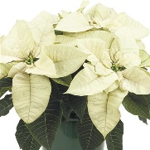 | White
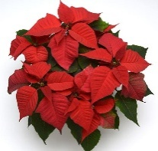 | Red
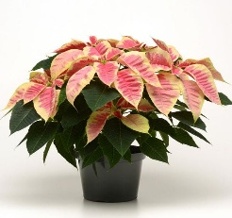 | Christmas Beauty Marble  White edge with pink center
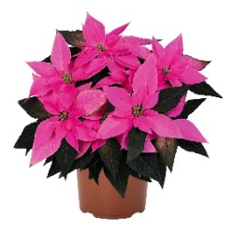 | J’ Adore Dark Pink  Similar to Luv U Pink
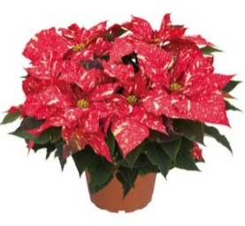 | Red Glitter  Red with white flecks
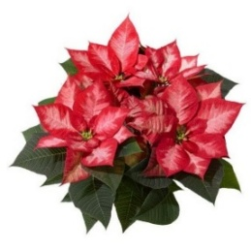 | Christmas Beauty Princess  Red with pale center
If applicable: Dos Valles Member taking order____________________________
BUSINESS ORDERS DELIVERED ON FRI 12/4/2026

